The LLN Meaning, Proof, Simulations

Marco Pasciullo

2094810

1. **LLN**

The law of large numbers 1 has a very central role in probability and statistics. It states that if you repeat an experiment independently a large number of times and average the result, what you obtain should be close to the expected value. There are two main versions of the law of large numbers. They are called the weak and strong laws of the large numbers. The difference between them is mostly theoretical. Before discussing the WLLN, let us define the sample mean. The LLN only applies to the average of the results obtained from repeated trials and claims that this average converges to the expected value; it does not claim that the sum of n results gets close to the expected value times n as n increases.

There are two different versions of the law of large numbers that are described below. They are called the **strong law of large numbers** and the **weak law of large numbers**. Stated for the case where X1, X2, ... is an infinite sequence of independent and identically distributed (i.i.d.) Lebesgue integrable random variables with expected value E(X1) = E(X2) = ... = µ, both versions of the law state that the sample average

*Definition.* For i.i.d. random variables X1,X2,...,Xn, the sample mean, de-noted by X, is defined as

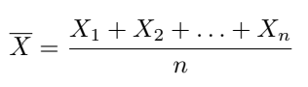

converges to the expected value:

Introductory probability texts often additionally assume identical finite variance:



and no correlation between random variables. In that case, the variance of the average of n random variables is:



1. **WEAK LAW**

A LLN is called a Weak Law of Large Numbers (WLLN) if the sample mean converges in probability.

The adjective weak is used because convergence in probability is often called weak convergence. It is employed to make a distinction from Strong Laws of Large Numbers, in which the sample mean is required to converge almost surely.

* 1. **Chebyshev's Weak Law of Large Numbers**

One of the best known WLLNs is Chebyshev's.

Proposition (Chebyshev's WLLN) Let [EQ1] be an uncorrelated and covariance stationary sequence:

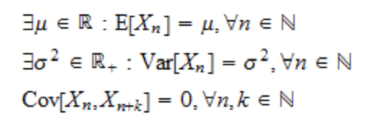

Then, a Weak Law of Large Numbers applies to the sample mean:

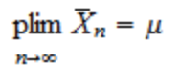

where **plim** denotes a probability limit.

**Proof**

Note that it is customary to state Chebyshev's Weak Law of Large Numbers as a result on the convergence in probability of the sample mean:

However, the conditions of the above theorem guarantee the **mean square convergence** of the sample mean to u:

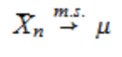

Hence, in Chebyshev's WLLN, convergence in probability is just a consequence of the fact that **convergence in mean square implies convergence in probability.**

1. **STRONG LAW**

A LLN is called a Strong Law of Large Numbers (SLLN) if the sample mean **converges almost surely**.

The adjective Strong is used to make a distinction from Weak Laws of Large Numbers, where the sample mean is required to converge in probability.

**3.1) Kolmogorov's Strong Law of Large Numbers**

Among SLLNs, Kolmogorov's is probably the best known.

Proposition (Kolmogorov's SLLN) Let {Xn} be an **iid sequence** of random variables having finite mean:



Then, a Strong Law of Large Numbers applies to the sample mean:

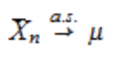

Where (a.s ->) denote **almost sure convergence**.

1. **SIMULATION**

Practical simulations were conducted by rolling a virtual die numerous time. The average value of the outcomes was calculated for increasing numbers of rolls, and the results were graphed. These simulations visually demonstrate how the average converges towards 3.5 as the number of rolls increases.

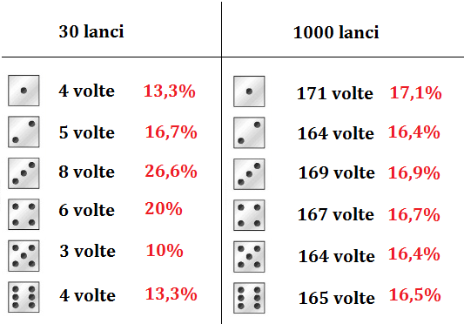

The example of dice rolls provides a tangible illustration of the LLN in action. Whether through mathematical proof or practical simulations, the LLN consistently reveals that, with a sufficient number of trials, the observed average aligns closely with the expected average. Understanding the LLN enhances our ability to interpret and predict outcomes in probabilistic scenarios.